Individual Pathways
Activity 9.1
Revising energy transmission

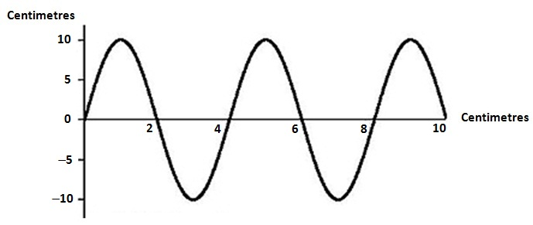

- What type of wave is shown in the diagram above? ......................................................

- Give an example of energy that travels in this type of wave.
.........................................................................................................................................

- On the diagram above, draw and label arrows to represent
- the wavelength
- the amplitude of the wave.

- Generally, the speed of sound through a material depends upon how close together the particles of that material are and how elastic it is. The greater the ease with which collisions between particles (which transfer kinetic energy) can occur, the faster a sound wave can travel through the material. The following table gives you the speed at which sound waves travel through a variety of materials.

Material | Speed of sound (m/s)
Air (0 °C) | 331
Air (20 °C) | 344
Water (pure) | 1498
Sea water | 1540
Alcohol | 1207
Blood (37 °C) | 1570
Body tissue (37 °C) | 1570
Aluminium | 5100
Copper | 3900
Concrete | 4500
Granite | 5000
Lead | 1960
Glass (Pyrex) | 5170
Iron | 5120
Steel | 4700–6000  (average 5400)
Wood | 4000–5300

- Looking at the values in this table, what generalisation can you make about the speed of sound in liquids compared to its speed in solids and in gases?
...........................................................................................................................................................................................................................................................................................................................................................................................................................

- In movies you may see someone trying to tell if a train is coming by pressing their ear against the steel rail of the train track. Explain why this would be any better than just trying to hear the sound of the train coming through the air. (Hint: through which does sound travel faster?)
...........................................................................................................................................................................................................................................................................................................................................................................................................................

- Insert the following words into the diagram of the auditory system below.

Cochlea | Eustachian tube | Ear drum
Auricle | Auditory nerve | Ear canal

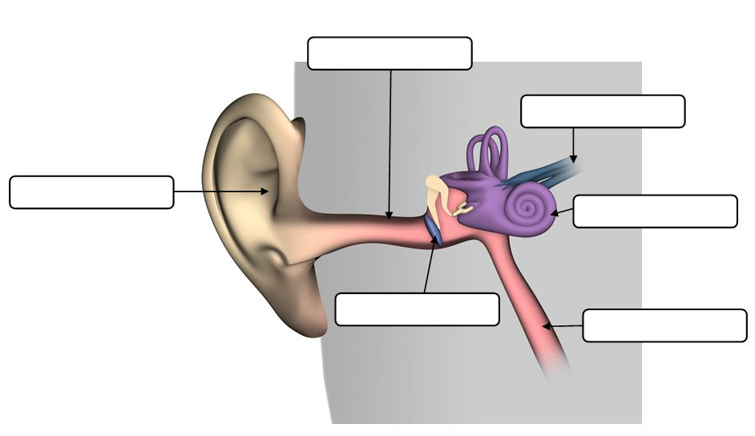

- Complete the table below by placing one of the types of electromagnetic waves next to its description.

Visible light | Radio waves | X-rays | Ultraviolet radiation

Type of electromagnetic wave | Description
 | Invisible to the human eye. The body needs it to form vitamin D but too much can give you a sunburn.
 | Used to form images that show what’s under your skin. It can also be used to kill cancer cells and detect flaws in metal components.
 | Necessary for our sense of sight and for plants to perform photosynthesis. It is only a very small section of the electromagnetic spectrum.
 | These are low-energy waves used to communicate over long distances. They include radar and microwaves.

- Use the terms below to identify the lenses and mirrors shown.

Concave mirror | Convex mirror | Converging lens | Diverging lens

- (ii)
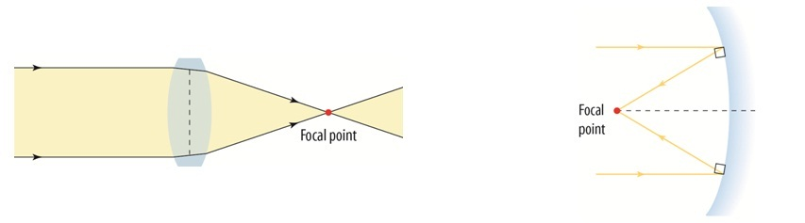
...................................................... ......................................................
(iii) (iv)
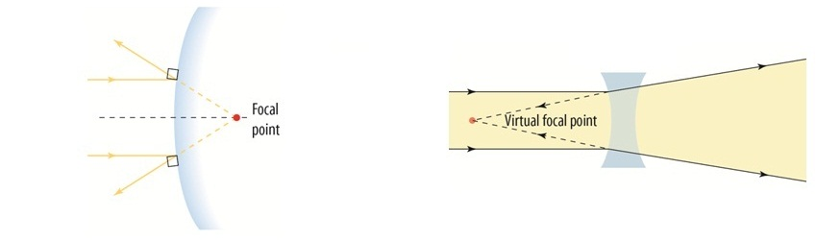
...................................................... ......................................................

- Which of the mirrors or lenses above would you use as a magnifying glass?
....................................................................

- Which of the mirrors or lenses above would you find being used at an intersection so that drivers can see around a blind corner?
....................................................................

- At the moment, we are in the process of changing over from analogue TV signals to digital TV signals. Give at least two advantages that digital TV will have over analogue TV.
................................................................................................................................................................................................................................................................................................
Answers
1.
- Transverse wave
- Examples may include electromagnetic radiation/light and ocean waves.

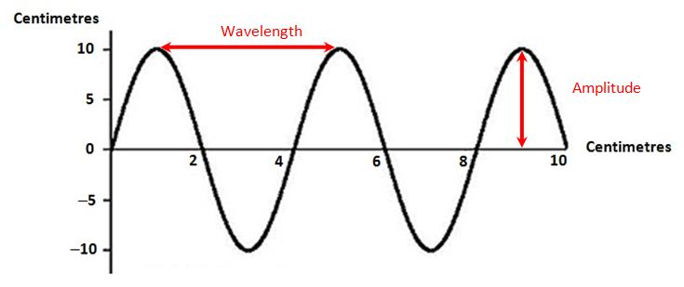

2.
- The speed of sound in liquids is higher than it is in gases, but is slower than its speed in solids.
- The speed of sound in steel is about 5400 m/s compared to 344 m/s in air. This means that the sound of the train’s approach can be heard through the track long before you would hear it through the air.

3.
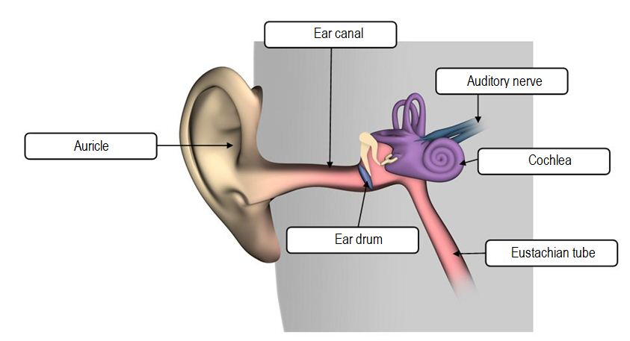

4.
Type of electromagnetic wave | Description
Ultraviolet radiation | Invisible to the human eye. The body needs it to form vitamin D but too much can give you a sunburn.
X-rays | Used to form images that show what’s under your skin. It can also be used to kill cancer cells and detect flaws in metal components.
Visible light | Necessary for our sense of sight and for plants to perform photosynthesis. It is only a very small section of the electromagnetic spectrum.
Radio waves | These are low-energy waves used to communicate over long distances. They include radar and microwaves.

- Converging lens
- Concave mirror
- Convex mirror
- Diverging lens
- Converging lens
- Convex mirror

- Responses may include two of the following.
- Sharper images
- Better sound quality
- Access to internet and email onscreen
- Capability of surround sound option
- Capability of interactive TV options
- Ability to access electronic program guides

